**

**Mathematics Specialist Unit 2 - 2020**

# Test 6

**Complex Numbers and Matrices**

|  |
| --- |
| **Name: ______________________ Total Marks:__________** |
|  |
|  |

**Task type: Response**

**Time allowed for this task:** 60 minutes, in-class, under test conditions

Section One: Calculator-free 33minutes ( 30 marks)

(3 Minutes Reading – 30 Minutes Working)

Section Two: Calculator-assumed 25 minutes ( 25 marks)

(2 minutes Reading - 25minutes working)

**Materials required:** Calculator with CAS capability (to be provided by the student)

**Standard items:** Pens (blue/black preferred), pencils (including coloured), sharpener, correction fluid/tape, eraser, ruler, highlighters

**Special items:**  Drawing instruments, templates, notes on one unfolded sheet of   
A4 paper, and up to three calculators approved for use in the WACE examinations

Formula sheet

**Marks available: 56 marks**

**Task weighting: 7%**

**Section One : Calculator Free 30 Marks**

**Time Allowed 30 minutes**



Question 1 (8 marks)

Let and . Find



**Question 2**

**[2 marks]**

If . Find and .



Question 3

[4 marks]

A point is reflected in the y-axis and then rotated 90 clockwise about the origin.

1. Find the matrix T that will combine these two transformations.

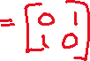

1. The point A has coordinates after being transformed by matrix T. Find the coordinates of point A.

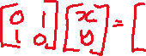

Question 4

[3 marks]

Determine all complex solutions to the equation .



**Question 5**

**[4 marks]**

Determine the values of the real constants and if is a solution of the equation

.



**Question 6**

**[3 marks]**

Express the real quadratic polynomial as a product of its linear factors.

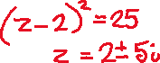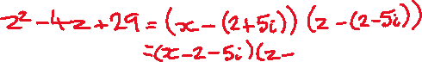

Question 7

[3 marks]

Determine the values of the **positive** real constants and so that is a solution to the equation

.



**Question 8**

**[3 marks]**

Prove that the product of a complex number and its conjugate is a real number.

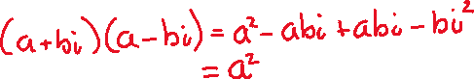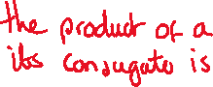

**Section Two : Calculator Assumed 25 Marks**

**Time Allowed 25 minutes Name:_______________________**

Question 9

[5 marks]

Show the following numbers as vectors on a single Argand diagram.

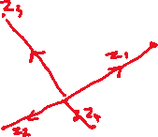

**Question 10**

**[4 marks]**

1. Find the transformation matrix representing a rotation of 30 anti-clockwise about the origin

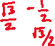

1. Find the transformation matrix representing a rotation of 45 anti-clockwise about the origin.

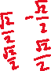

1. Hence, find the transformation matrix that represents a 75 anti-clockwise rotation about the origin.

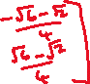

**Question 11**

**[3 marks]**

Use matrices to find the image of the line after it is reflected in the line.

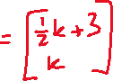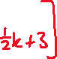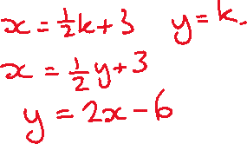

**Question 12**

**[3 marks]**

1. What is the matrix for the transformation T: (x, y)  (4x – 3y, x + 5y)?



1. Find the image of the trapezium A(3, –2) B(5, 3) C(1, 6) D(–3, –4) under the transformation T.



**Question 13**



**[10 marks]**

A triangle has vertices at , and and is transformed to triangle by the matrix .

1. Find the coordinates of

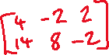

Triangle is then transformed to triangle by matrix. The vertices of triangle are

.

1. Find matrix



The area of triangle is 42 cm2.

1. Find the areas of and .

